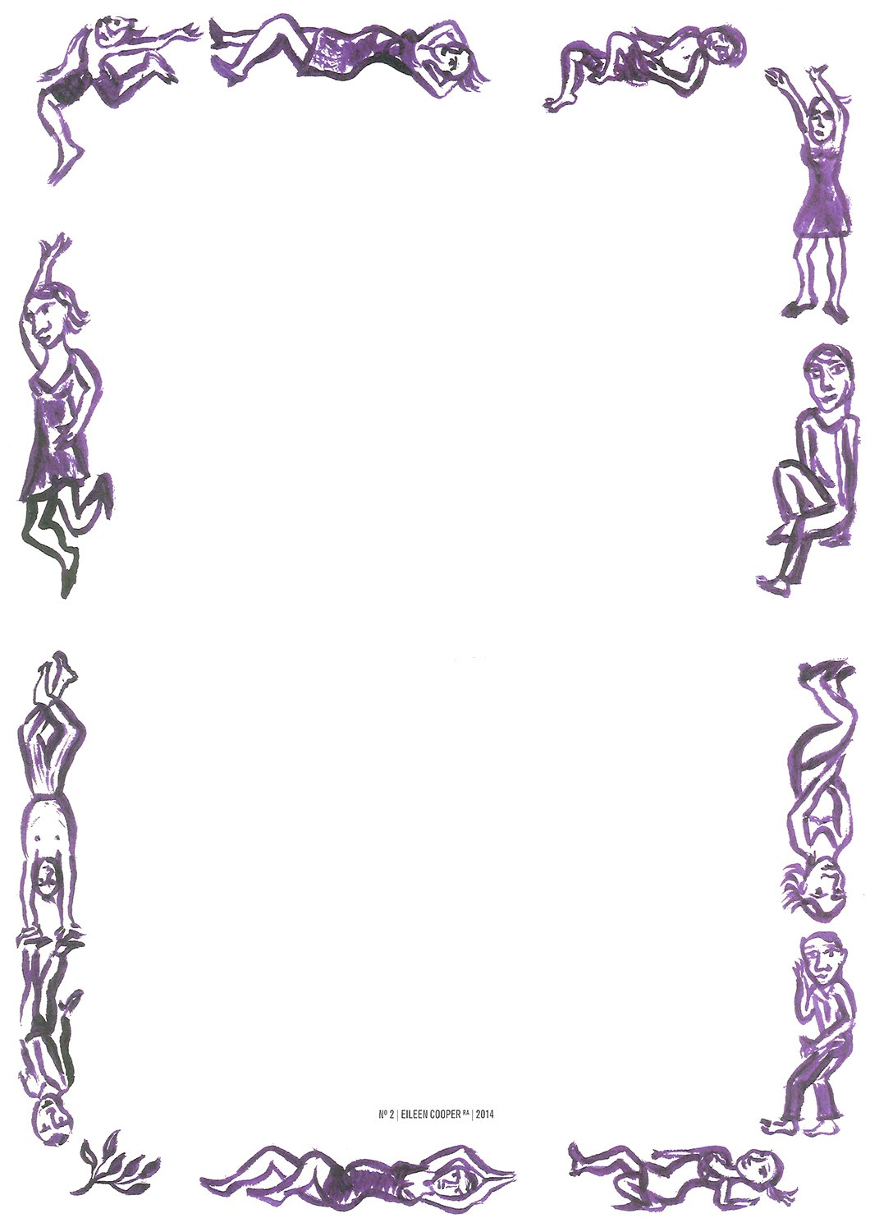

**Christmas Menu**

*3 courses - £35 pp*

**Starters**

Roasted chestnut and pumpkin soup with pumpkin seeds

Coarse game and pistachio terrine homemade gooseberry relish and sourdough toast

Slipmith Gin cured sea trout with fennel and horseradish salad

Red Onion tarte tatin with Bishop Stilton cheese, caramelised walnuts and winter leaves

**Mains**

Celeriac and cox apple risotto, parsnip crisps, watercress oil and toasted hazelnuts

Honey roasted breast of English duck, fondant potato, mulled wine spiced cabbage, blackberries

Seared Scottish salmon, king scallops, puy lentils and butternut emulsion

Roasted Bronze turkey, savoy cabbage, confit carrots, duck fat roasties, sage jus and all the trimming

**Desserts**

Traditional Christmas pudding, Amaretto cream

Bitter chocolate and salted caramel tart with crème fraiche

Pedro Ximenez old-fashion Sherry Trifle

Shropshire Blue with port and oatcakes

--

Homemade mince pies with muscovado cream

A discretionary service charge of 12.5% will be added to your bill

*All of our dishes are prepared in an environment where nuts are present. Please let us know if you have any dietary requirements and we shall do our best to accommodate.*